**KEYWORD TABLE**

1. 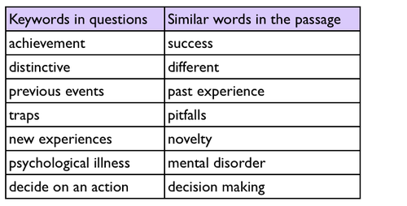Reading test 2, passage 3 in Cambridge IELTS book 9.
2. 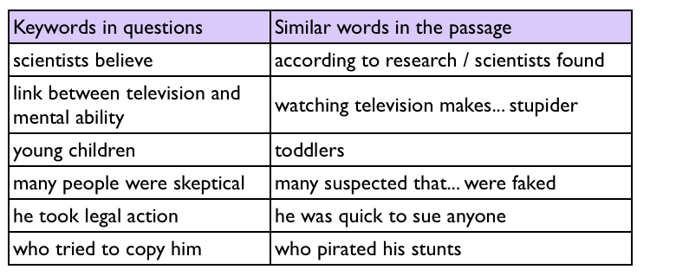reading exercise from Simon’s website 1
3. test 3, passage 3 in Cambridge IELTS book 5

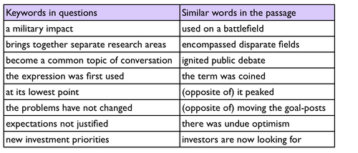

1. Cambridge IELTS 8 (test 1, passage 1)

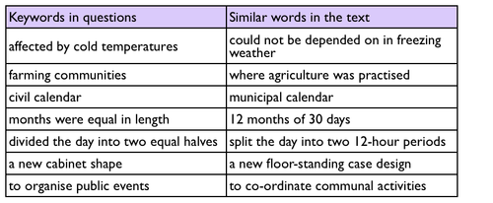

1. reading test on page 109 of Cambridge IELTS book 9

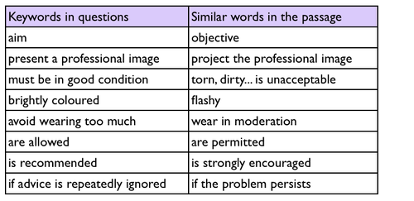

1. reading test 3, passage 3 in Cambridge IELTS book 4

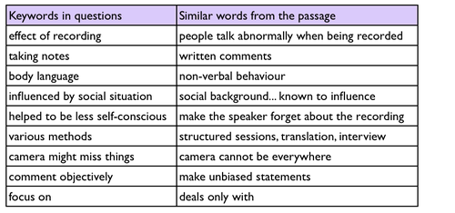

1. the general test questions on page 122 of Cambridge book 4

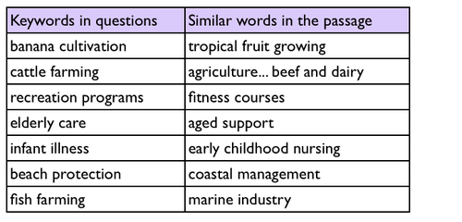

1. reading exercise from Simon’s website 2

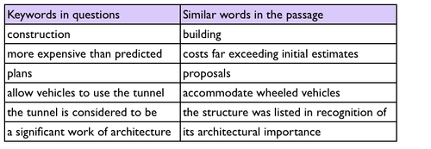

1. passage 2 of test 3 in Cambridge IELTS book 9 (page 67)

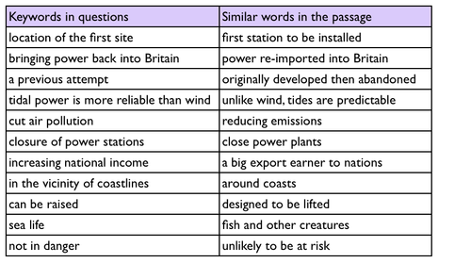

1. the reading test on page 74-77 in Cambridge IELTS book 4

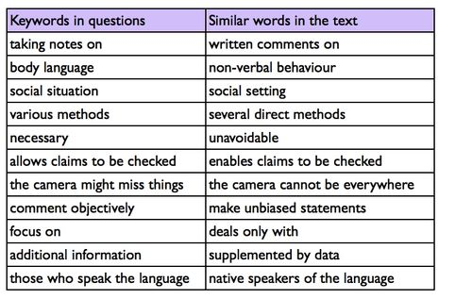

1. test 1, passage 2 in Cambridge IELTS 7

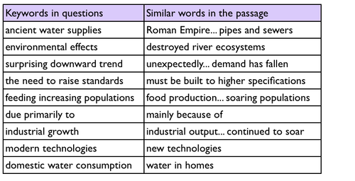

1. the test on page 122 of Cambridge IELTS 6

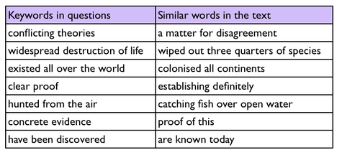

1. Cambridge book 9 test 2

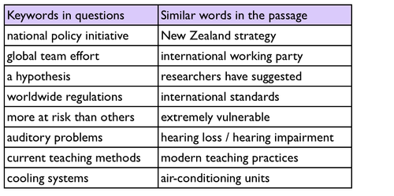

1. Reading from Simon’s web 3  
   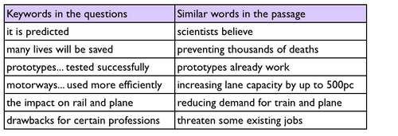
2. test 4, passage 2 in Cambridge IELTS book 4

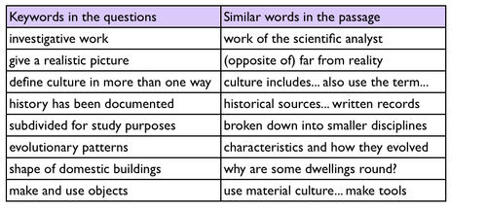

1. test 1, passage 1 in Cambridge IELTS book 4

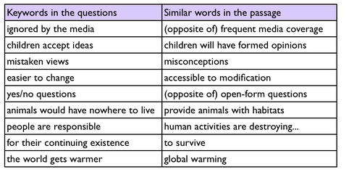

1. test 1, passage 3 in Cambridge IELTS 6

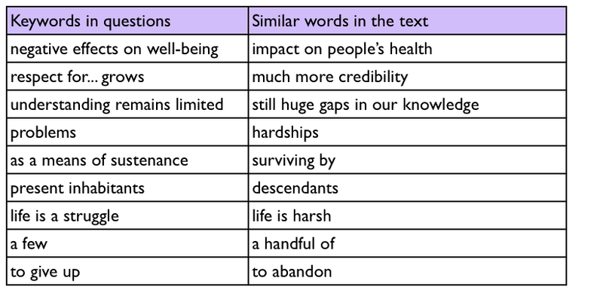

1. the General reading test on page 116 of Cambridge IELTS 6

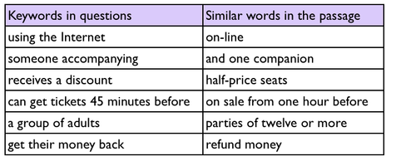

1. Reading from Simon’s web 4  
   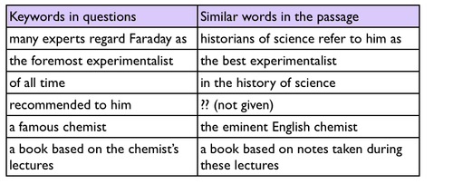
2. test 2, passage 2 in Cambridge IELTS book 8

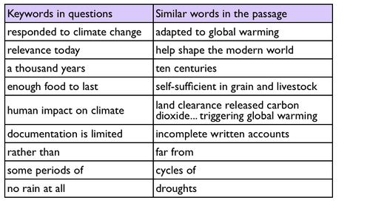

1. reading test 2, passage 3 in Cambridge IELTS book 8

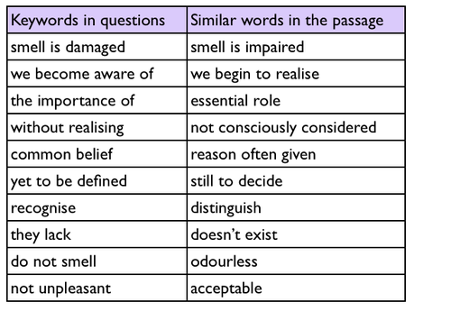

1. the test on page 24 of Cambridge IELTS book 5.

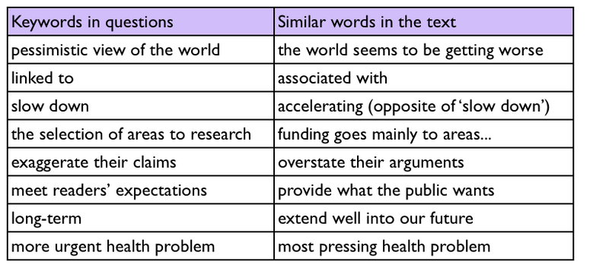

1. Reading from Simon’s web 5

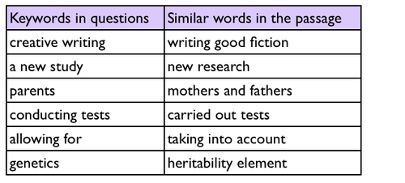

1. reading test 4.1 in Cambridge IELTS book 7

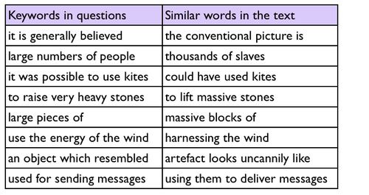

1. Reading from Simon’s web 6

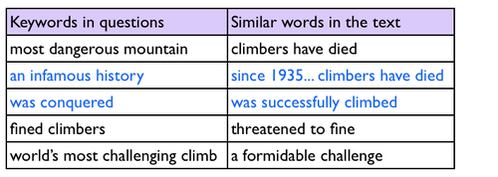

1. the test on page 46-49 of Cambridge IELTS book 4

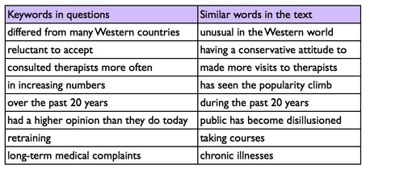

1. the GT test in Cambridge book 6, page 118

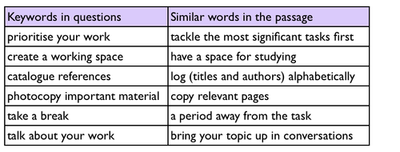

1. test 1.3 in Cambridge IELTS book 4

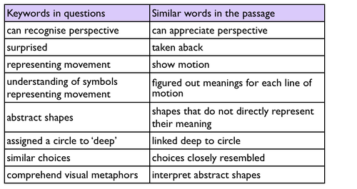

1. reading test from Cambridge IELTS 7 (page 48-52)

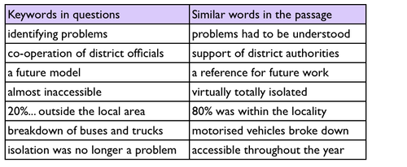

1. Reading from Simon’s web 7

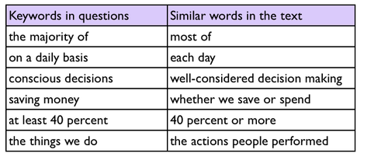

1. test 4, passage 1 in Cambridge IELTS book 6

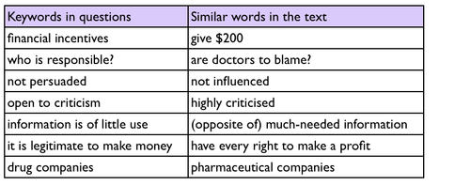

1. Test 4 in Cambridge IELTS book 4

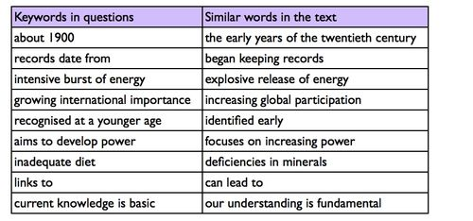

1. test 1, passage 1 in Cambridge IELTS book 6

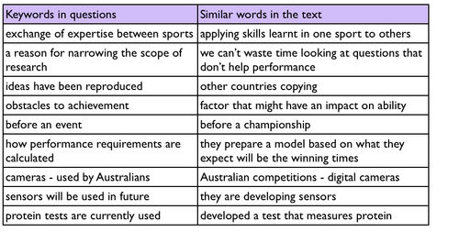

1. reading test (Cambridge IELTS 5, page 94-97)

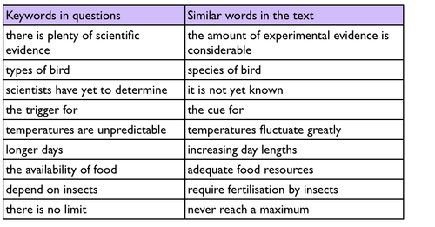

1. Cambridge IELTS 4 (test 1, passage 2)

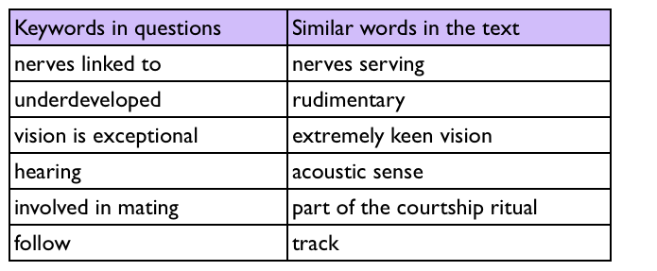

1. a reading test in Cambridge IELTS Book 1 (page 40-43)

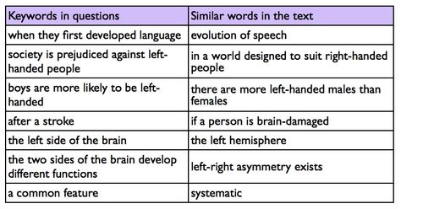

1. he test on page 50-53 in Cambridge IELTS book 4

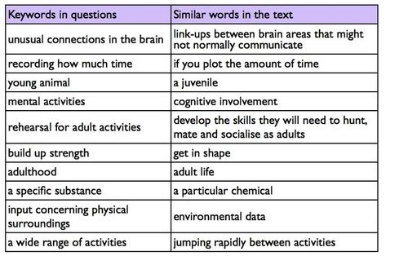

1. the test on page 60-63 of Cambridge IELTS book 1

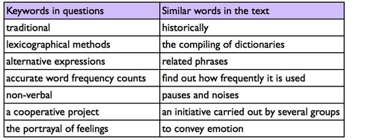

1. the reading test on page 40 of Cambridge IELTS book 6

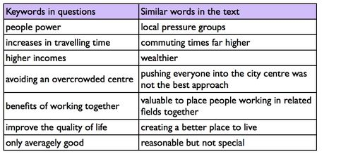

1. Reading from Simon’s web 9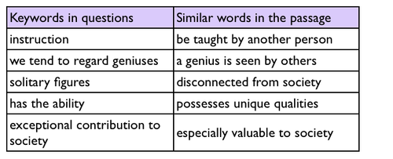
2. reading test 2, passage 3 in Cambridge IELTS book 9



1. Reading from Simon’s web 13

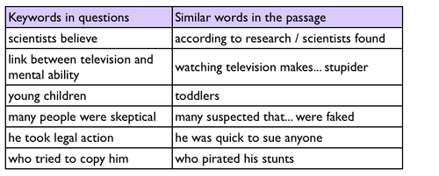

1. test 3, passage 3 in Cambridge IELTS book 5.

